

2021 MAA State Field Championship

When: Saturday August 28^{th and} Sunday August 29th 2021
Where: Tuscarora Archers 5608 Etzler Road Frederick, MD 21702
Pre-registration mailing deadline: PLEASE EMAIL REGISTRATIONS TO 3dlvr69@gmail.com prior to August 22, 2021.
Emergency calls only at: 443-714-4507
Late registration: ONLY IF SPACE IS AVAILABLE, AT LEAST ONE HOUR PRIOR.
Registration fees: MSR & SSR-$20 / ADULT, SR’S Y-ADULT-$25 / YOUTH & CUB $15 / FAMILY-$70
MUST SHOOT BOTH DAYS AND FINISH FOR YOUR SCORES TO COUNT!!!
PROOF OF MAA/ NFAA MEMBERSHIP REQUIRED AT CHECK-IN

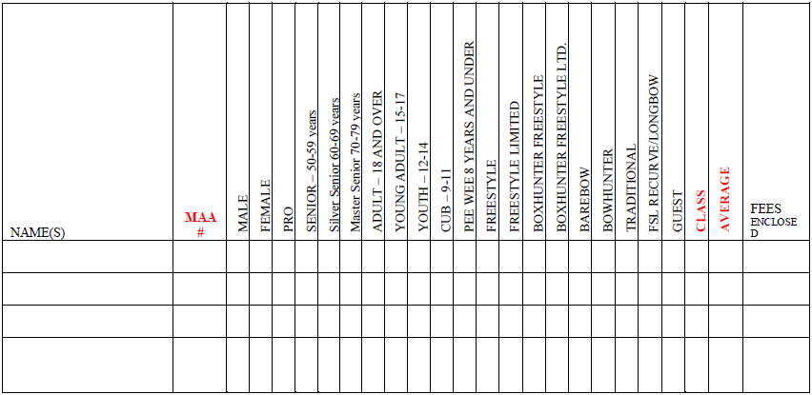

Phone:____________________________ AND Email: ______________________________________

CLUB:_____________________________

Please make checks payable to MAA and send to Tournament Director Raymon Hamzidkhan 12969 Mohawk Dr. Lusby, MD 20657

